**WEEKLY REPORT DE BENEDETTI MATTEO**

**WEEK 9: 28/10/2019 – 01/11/2019**

VISUAL ODOMETRY IMPROVEMENTS

I continued working on trying to improve the Viso2 library and alongside a colleague to improve the Spartan library.  
After an intensive recalibration of the camera better results were achieved, pushing Spartan to 1% error and Viso2 to 3% error.

After testing the Spartan VO on a 5m traverse at 0.03 m/s and obtaining the following results, it has been decided to proceed with the Spartan library.

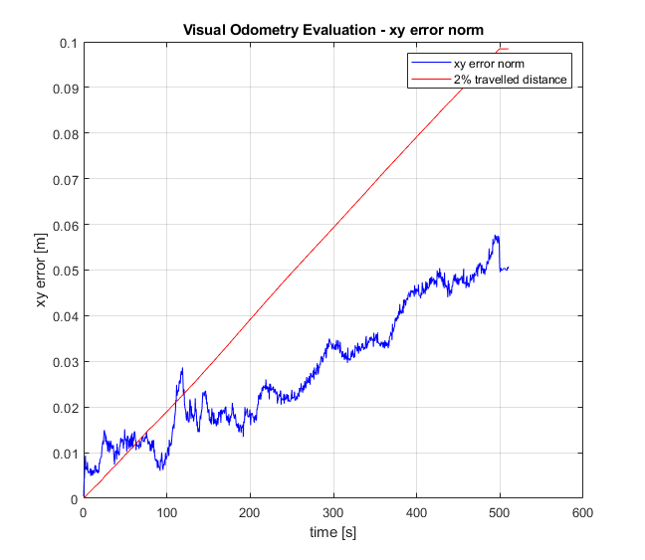

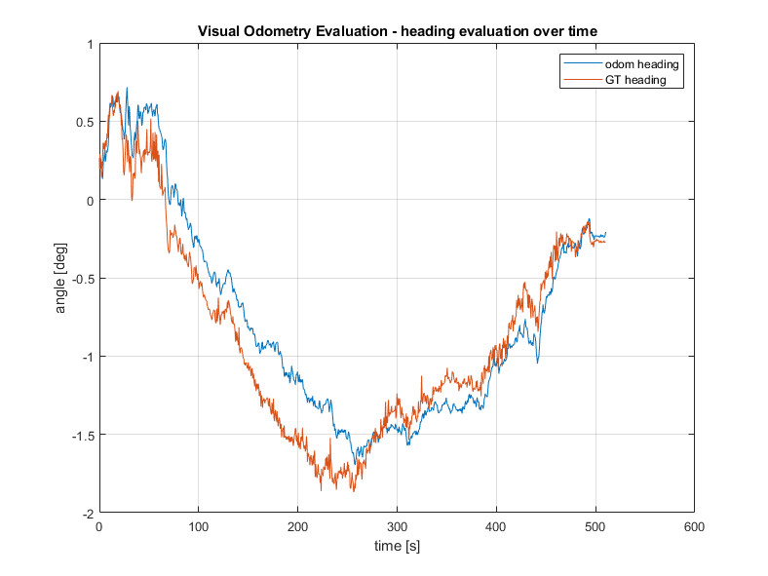

I have then worked on making it fully compatible with the ROcK Environment so a new script, similar to the one developed for viso2, was developed to control the rover and run the Spartan VO with a log of the motion commands and the required sensors (vicon and camera) instead of via the joystick.

VO TESTS:

The tests has been further defined and the objective is to start by studying the behavior of the Spartan VO at different velocities.  
*Velocity* has an effect on many other factors like the *overlap percentage* between two frames (that can be also influenced by the *frequency* that the VO runs at) the *blurriness* of the image (that can be mitigated decreasing the *exposure time*, at the cost of reduced *image brightness*, that can also be influenced by the *ambient light*).

In summary, the parameters that will be initially studied and varied, to better understand the effect they have on VO performances and also how they affect each other, are:

* Translational speed of the rover
* VO frequency
* Exposure time
* Ambient light

A first set of tests has been defined with the objective of trying to find the effect of only the translational velocity on the VO performances.

After this a new set of tests will be performed fixing the velocity and changing the VO frequency, with the objective of varying the image overlap percentage, and see if and how it affects the VO performances.

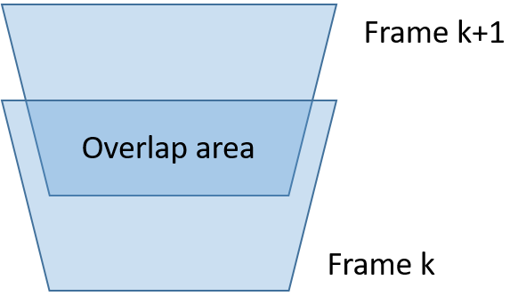  
To estimate the overlap percentage between two frames, a function has been defined that, given the camera height and pitch, VO frequency, rover speed and both horizontal and vertical FoV, outputs an overlap percentage.

FUTURE OBJECTIVES:

The next objective is to start performing the tests previously described where only the translational velocity is varied.  
A set on input data (motion commands, vicon and camera frames) at the following speed has already been collected: 0.01, 0.02, 0.03, 0.04, 0.05, 0.06, 0.07, 0.08, 0.09 m/s.

It could also be interesting to see if the Spartan VO improves by adding the IMU measurements and fusing them with the VO output for the computation of the orientation.